**Think Like a Canadian Economist**

**Episode 11. Job gains and losses**

**Video Script**

On the first or second Friday of every month, the release of Statistics Canada’s job numbers dominates the news cycle, with headlines like “Jobs Growth Points to Economic Resurgence in Third Quarter”, or “Canada Adds 12,000 Jobs in August, but unemployment rate rises to 7%”.

Because employment normally moves in the same direction as the business cycle, households, businesses, investors, economists, and the media watch these numbers carefully as an early signal of the direction the economy is moving.

For example, people might see a month with large job losses as a sign that we’re headed for a recession. When the reported change in jobs is different from what people expected, we sometimes see instant changes in financial markets and the exchange rate as people work the new information into their decisions.

With the amount of attention it gets each month, it’s important to understand how to interpret this information.

The first step is to understand where the numbers come from. Ideally, Statistics Canada would ask everyone in the population about their work status, and report those numbers. But, this would cost too much in terms of both money and time. Instead, they base their numbers on a survey of households called the “Labour Force Survey”. This survey asks a sample of about 56,000 households - excluding people in the Armed Forces full time, the institutionalized, or living on reserve - a series of questions about their work status, hours worked, and other relevant information. They treat each surveyed household as representative of several households in the population, so that when they add up the job numbers, they approximate employment numbers for the population as a whole.

Now that we know where the numbers come from, how should we interpret them? The media tends to focus on the change in employment from month to month. Let’s take the August 2015 numbers as an example, which stated that the economy gained 12,000 jobs between July and August. Because it’s based on a sample from the population, there are 2 key reasons why we report a 12,000 job gain:

1) First, the actual number of jobs really changed

2) Second, the sample is different from the population as a whole, so the job change we measured from the sample is not quite the same as the real one from the population. This is called “sampling error”.

Because we have only the one sample, we will never know what part of that 12,000 change is real, and what part is sampling error. For this reason, it’s usually not a good idea to interpret job change numbers literally.

But this doesn’t mean the information is useless. We can use statistical theory to estimate how much sampling error is normal from sample to sample, called the “standard error”. We then use the standard error to make an educated guess at the range of values that contains the real change in jobs.

Right now the standard error for month-to-month changes in jobs is about 29,100. According to statistical theory, the change in jobs we measure will be up to 1 standard error above or below the real value in 68% of LFS samples.

So, if we guess that the real change in jobs is within 1 standard error of our measured value, we have a 68% chance of being right.

For the August job numbers, our guess would be that the real value is between -17,100 and 41,100. Unfortunately, a 68% chance of being right means a 32% chance of being wrong, and for this reason most economists wouldn’t place a lot of confidence in this guess.

We can be more confident if we widen the range. Statistical theory also tells us that the change in jobs we measure will be up to 2 standard errors above or below the real value in 95% of samples. So, if we instead guess that the real change in jobs is within 2 standard errors our measured value, we have a 95% chance of being right. For the August numbers, this range is -46,200 to 70,200. Most economists would be much more comfortable with this guess, because it has a small chance of being wrong. If we wanted, we could increase our confidence even more by widening the range further.

Because the typical error is so big compared to the measured job gains for August, our best guesses are huge intervals containing negative values, zero, and positive values. And because all we can say is that the real value is probably somewhere in the range, small changes in jobs like 12,000 tell us nothing useful.

To say anything meaningful, the measured change should be bigger than twice the standard error. That is, unless Statistics Canada reports that jobs grow or shrink by at least 58, 200, our best guess at the real change in jobs includes zero. Since January 2006, this has only happened in 12 months.

The takeaway here is that unless job changes are very large from one month to the next, we can’t put any stock in those values. Instead, it’s best to use these numbers to track trends over longer periods. This graph shows the monthly job changes in Canada since 2006. You can see the change bounce around a lot from month to month, but you also see a pattern of falling job growth just before the recession, the recession itself, and then a slowly falling pattern of growth again.

More generally, economists would recommend ignoring these monthly changes altogether, and look directly at the longer-run trends in employment and unemployment that matter a lot more.

Follow us on twitter @tlcecon, and visit our website for more videos.

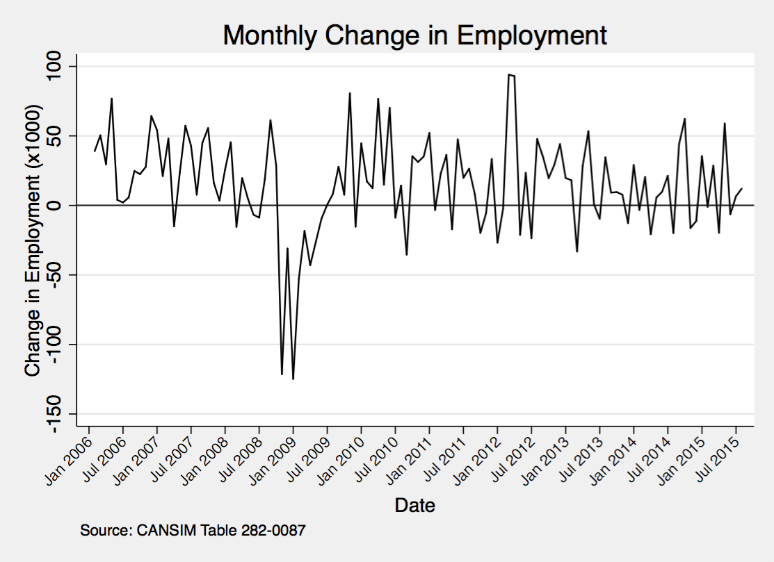

Unemployment rates were also taken from CANSIM Table 282-0087.